Supplemental Material

High mitogenome-wide rates of evolution and time dependency
Sankar Subramanian^{1, 2}, Dee R. Denver^{3, 4}, Craig D. Millar², Tim Heupink³, Angelique Aschrafi^{3, 5}, Steven D. Emslie⁶ Carlo Baroni⁷ and David M. Lambert^{1, 3}∗

¹Griffith School of Environment and the School of Biomolecular and Physical Sciences, Griffith University, 170 Kessels Road, Nathan, Qld 4111 Australia.
²Allan Wilson Centre for Molecular Ecology and Evolution, School of Biological Sciences, University of Auckland, Private Bag 92019, Auckland, New Zealand.
³Allan Wilson Centre for Molecular Ecology and Evolution, Institute of Molecular BioSciences, Massey University, Auckland, New Zealand.
⁴Department of Zoology and Center for Genome Research and Biocomputing, Oregon State University, Corvallis, Oregon, USA.
⁵Department of Cell Biology, The Scripps Research Institute, La Jolla, California 92037, USA.
⁶Department of Biology and Marine Biology, University of North Carolina, Willmington, North Carolina, USA.
⁷ Dipartmento Scienze della Terra, Universita` di Pisa, and Consiglio Nazionale Ricerche, Centro Studio Geologia Strutturale, Pisa, Italy.

Stratigraphy and ¹⁴C Dating
Sub-fossil Adélie penguin bones were collected from six locations in Antarctica (Figure 1) [1] Radiocarbon dates were supplied by Geochron Laboratory - Krueger Enterprise Inc., Cambridge, Massachusetts (conventional and AMS, GX-), IsoTrace Radiocarbon Laboratory, Toronto (AMS, TO-) and NOSAMS, Woods Hole Oceanographic Institute (AMS, OS-) and the New Zealand Institute of Geological and Nuclear Sciences, Lower Hutt, New Zealand (AMS, NZA-).

DNA extraction
Shavings of bone were taken from samples using a sterile surgical blade. About 200mg of bone material was transferred to a sterile Eppendorf tube. In between samples bench area and blade were cleaned using 10% bleach. After adding 1.5ml of 0.5M EDTA and 0.75mg of proteinase-K, the samples were rotated overnight at 56°C. Samples were then extracted once with Tris-saturated phenol, once with Tris-saturated phenol: chloroform: isoamyl-alcohol (25:24:1) and finally once with chloroform: isoamyl-alcohol (24:1). This extracted solution was then concentrated to 50μL on a Vivaspin-30 (Viva Science, U.K.) membrane. The sample was then purified using QIAGEN DNA mini kit eluting in 50μL 1xTE and stored at -20°C. All DNA extractions and setting up of PCR’s from sub-fossil material were conducted in a dedicated ancient DNA laboratory, which underwent regular decontamination with UV-irradiation and hypochloride treatment. Mock DNA extractions and blank PCR’s were continually screened for contamination.

Multiplex PCR and Sequencing
Modern samples were extracted using a 10% Chelex 100 (Sigma-Aldrich) solution in 100mM Tris pH8.8. Amplification of the mitochondrial genomes was performed using a high throughput plate set up. The set up of the multiplex PCR is as described in a previously published protocol (Römlper et al. 2006). All samples where amplified using a two stage multiplex PCR, using 51 overlapping primer pairs and another 51 nested primer pairs (Table S1). The first stage 50µl multiplex reaction contained final concentrations of: 0.4µM of each primer (two reactions with 25 or 26 pairs), 1x PCR Buffer, 2.5mM MgCl₂, 0.2mM dNTPs, 1mg/ml BSA, 1.25 units of Platinum Taq DNA polymerase (Invitrogen) and 1µl of DNA extract. The thermo cycling was performed as follows: 4min 95 ºC, 35x (30 sec 95ºC, 30sec 55ºC, 45sec 72ºC), 10min 72ºC. The second stage 50µl simplex reaction contained final concentrations of: 0.25µM of each primer (51 reactions with one pair), 1x PCR Buffer, 2.5mM MgCl₂, 0.2mM dNTPs, 1mg/ml BSA, 1.25 units of Platinum Taq DNA polymerase and 1µl of 1:50 diluted 1st stage PCR product. The thermo cycling was performed as described for the first stage reaction.

PCR reactions were purified for sequencing using the AMPure kit according to manufacturer’s protocol. Samples where then subjected to ethanol precipitation and sequenced using the BigDye Terminator v3.1 cycle sequencing kit (ABI), according to manufacturer’s protocol.

Evolutionary rate estimation
The length of Adelie penguin mitochondrial genomes recovered varies between 12.5 – 16.1 kb (Figure S1). Amino acid sequences of each protein coding gene and the nucleotide sequences of each tRNA and rRNA gene were aligned by CLUSTAL-W [2]. The cDNA alignments of protein coding genes were created using the alignments of amino acid sequences. We employed a complete site deletion method by excluding the nucleotide positions that contained an alignment gap in one or more sequences. Fourfold and zerofold degenerate sites were extracted from the cDNA alignments. Our final dataset consists of 1349 fourfold degenerate positions, 4860 zerofold degenerate positions, 1136 tRNA and 1089 rRNA sites from 12 modern and eight ancient Adélie penguins. Pair-wise distance estimations were performed using MEGA [3].

To estimate the neutral evolutionary rate, only the fourfold degenerate sites were used. First a simple distance based evolutionary rate was estimated using a serial UPGMA method employed in the software Pebble under a HKY+Gamma model of evolution [4]. Furthermore Pebble was used to construct an UPGMA tree of modern and ancient Adélie penguins by accounting for the ages of the ancient sequences (Figure S2). The program TipDate [5] implemented in PAML [6] was used to estimate the rate of evolution by the maximum likelihood method using a GTR+Gamma model of evolution and the UPGMA tree was used to provide the topology.

We also employed Bayesian statistics based on a Markov chain Monte Carlo approach using the software BEAST [7] assuming a relaxed molecular clock, constant population size and GTR+Gamma model of evolution. Wide uniform prior distributions were used to avoid any bias due to restricted prior assumptions. The rate estimate and the highest posterior density intervals were similar when varying a number of a priori assumptions. The rate estimates were sampled once every 1000 cycles from the total MCMC chain length of 10,000,000 after discarding the initial 1,000,000 burn-in 1,000,000 steps. The posterior distributions were examined using the software TRACER [8] and the Effective Sample Sizes (ESS) for mean evolutionary rate, population size and posterior likelihood were found to be >100 for all the models used.

To estimate the root height (μt_{MRCA}, substitutions per site) of the most recent common ancestor the MCMCcoal was used [9]. μt_{MRCA}s were A, RS and A/RS lineages using synonymous (third) positions and also using constrained sites including nonsynonymous sites, tRNAs and rRNAs.

Table S1. External and Internal primers used to amplify complete Adélie penguin mitochondrial genomes. Plate = name of master primer plate. Row and Col depict location in master primer plates. Gapdh and Zenk are nuclear loci used to monitor the presence of nuclear DNA.

PLATE | ROW | COL | PRIMERNAME | PRIMER SEQ
Pa_mt_External | A | 1 | PaMTOF01 | AACCAAAGCATGGCACTGAAGAT
Pa_mt_External | E | 1 | PaMTOF02 | TTAACTGTCACACGGCGTAAAGA
Pa_mt_External | A | 3 | PaMTOF03 | TCGCCTGAAAGAACAACAGTGA
Pa_mt_External | E | 3 | PaMTOF04 | AACACAAAGCACTCAGCTTACACCT
Pa_mt_External | A | 5 | PaMTOF05 | AGTGGGATGACTTGTTAGTAGAGGT
Pa_mt_External | E | 5 | PaMTOF06 | AAGCGCAAGCTTACATCACCACATT
Pa_mt_External | A | 7 | PaMTOF07 | ACTGTCTCTTGCAGACAATCAATG
Pa_mt_External | E | 7 | PaMTOF08 | TTTACGACCTCGATGTTGGATCA
Pa_mt_External | A | 9 | PaMTOF09 | ATCCCAATCCTAGTCGCAGT
Pa_mt_External | E | 9 | PaMTOF10 | TATGATCAGGGTGGGCCTCAAA
Pa_mt_External | A | 11 | PaMTOF11 | GCAGGTCCATTCGCTTTATTCTT
Pa_mt_External | E | 11 | PaMTOF12 | CAACCCTCTCATTTCCTGAGATACA
Pa_mt_External | B | 1 | PaMTOF13 | TTCACAGGACAGTGAGACATCA
Pa_mt_External | F | 1 | PaMTOF14 | CCCAAACTTACCCTATTAACCTTCTACC
Pa_mt_External | B | 3 | PaMTOF15 | AGTTGCCATCCTTACCTCCTTAT
Pa_mt_External | F | 3 | PaMTOF16 | AAAGGACTACAGCCTAACGCCT
Pa_mt_External | B | 5 | PaMTOF17 | CCCGACATAGCATTTCCC
Pa_mt_External | F | 5 | PaMTOF18 | ACCGAAACCTAAACACTACCT
Pa_mt_External | B | 7 | PaMTOF19 | TGGGCTTCATCTTCCTCTTCACTAT
Pa_mt_External | F | 7 | PaMTOF20 | ATTCATCATCTGAGAAGCCCT
Pa_mt_External | B | 9 | PaMTOF21 | AATTCGGATTCCAAGATGCCT
Pa_mt_External | F | 9 | PaMTOF22 | ACATAATCCCAACAACAGACC
Pa_mt_External | B | 11 | PaMTOF23 | AATCGTAGTAGAATCTGCCC
Pa_mt_External | F | 11 | PaMTOF24 | AGGAATTCCGCTAATCCTACT
Pa_mt_External | C | 1 | PaMTOF25 | AATCGAAACCACTAGCCTACTCA
Pa_mt_External | G | 1 | PaMTOF26 | TAACCCTTGGCCTACTTTCCATA
Pa_mt_External | C | 3 | PaMTOF27 | AATCCACGCACTAACCCTAACAA
Pa_mt_External | G | 3 | PaMTOF28 | AATCACATTCATACTCACCCTCTCC
Pa_mt_External | C | 5 | PaMTOF29 | ATGAGTGAACACAAGGAGGCCTAGA
Pa_mt_External | G | 5 | PaMTOF30 | ATACTAGTTGCCTCAACCCGAA
Pa_mt_External | C | 7 | PaMTOF31 | AAACCACCTTCAACACGAACCT
Pa_mt_External | G | 7 | PaMTOF32 | AGCCCTACTAACAGCATTCATAGT
Pa_mt_External | C | 9 | PaMTOF33 | TCCGGTGCAATGATCCTCATAAT
Pa_mt_External | G | 9 | PaMTOF34 | ATACTACTAACAACCCAACGAGG
Pa_mt_External | C | 11 | PaMTOF35 | AACCAACAAGAGCTGCTAACT
Pa_mt_External | G | 11 | PaMTOF36 | GCATTACATCCTACTGAGAGTGA
Pa_mt_External | D | 1 | PaMTOF37 | TACAACCGAATCGGAGACATT
Pa_mt_External | H | 1 | PaMTOF38 | TAATAACCCAACTGCCCTCA
Pa_mt_External | D | 3 | PaMTOF39 | AGACCTCATTATCGAAAGCCT
Pa_mt_External | H | 3 | PaMTOF40 | ACCTAAACTTCTCCTCCTCCTTA
Pa_mt_External | D | 5 | PaMTOF41 | TGCCTGACTACACAAATCCTGA
Pa_mt_External | H | 5 | PaMTOF42 | ATATATTGGCCAAACCCTCGT
Pa_mt_External | D | 7 | PaMTOF43 | AACAAACTGGGAGGTGTCCTA
Pa_mt_External | H | 7 | PaMTOF44 | TGGTCTTGTAAGCCAAAGAGT
Pa_mt_External | D | 9 | PaMTOF45 | AACCCAACAACAAGCACCAAGAT
Pa_mt_External | H | 9 | PaMTOF46 | AAGTCATAGCAATTCCCGCTT
Pa_mt_External | D | 11 | PaMTOF47 | CATTTAATGTACGTACTAGGAC
Pa_mt_External | H | 11 | PaMTOF48 | GGACTGTCATGTAACAAACGACT
Pa_mt_External | A | 2 | PaMTOR01 | ACATCTTGGGCTTATGACAGCTT
Pa_mt_External | E | 2 | PaMTOR02 | AAATGTAGCCCATTTCTTCCACC
Pa_mt_External | A | 4 | PaMTOR03 | TTGGGCTAGAGTTTGGCTTCAA
Pa_mt_External | E | 4 | PaMTOR04 | TTCATTTCACAGGCAACCAGCTA
Pa_mt_External | A | 6 | PaMTOR05 | TGGGCTAACAGGGCAAGTTTAAT
Pa_mt_External | E | 6 | PaMTOR06 | TTTAAGTTCCACAGGGTCTTCTCGT
Pa_mt_External | A | 8 | PaMTOR07 | AATCGTTGAACAAACGAGCCCTT
Pa_mt_External | E | 8 | PaMTOR08 | TTTCGGGCTTGTATGTAGCTT
Pa_mt_External | A | 10 | PaMTOR09 | AAATAGTTTGTGCTACTGCCCGT
Pa_mt_External | E | 10 | PaMTOR10 | TGGGTTGAGAAACAGAATGGT
Pa_mt_External | A | 12 | PaMTOR11 | TTGATTTCTTCTGCGTAGGTTCG
Pa_mt_External | E | 12 | PaMTOR12 | ATTGCAATTGCTGCTGTCAGT
Pa_mt_External | B | 2 | PaMTOR13 | TCTTGGTTGTGTTGAGTGTGAGA
Pa_mt_External | F | 2 | PaMTOR14 | TCCTAAGTTTCTAGGTGGTTGCT
Pa_mt_External | B | 4 | PaMTOR15 | TGCCGATATCTTTGTGGTTGGTT
Pa_mt_External | F | 4 | PaMTOR16 | TTCTACTGTGGATGAGGCTAGT
Pa_mt_External | B | 6 | PaMTOR17 | AGAATCAGAAGAGGTGTTGGT
Pa_mt_External | F | 6 | PaMTOR18 | ATGTCCAATGAGGAGTTTGCT
Pa_mt_External | B | 8 | PaMTOR19 | TCATTCAATGTTGGTGGCAGT
Pa_mt_External | F | 8 | PaMTOR20 | TGCAGATTGCTAGGGCAACTATT
Pa_mt_External | B | 10 | PaMTOR21 | TAACAACACGGTGGTCTACTT
Pa_mt_External | F | 10 | PaMTOR22 | AGGCTAGTGCTGTTTCATAGCTT
Pa_mt_External | B | 12 | PaMTOR23 | ACGGTTGGTAATTCATCGGTT
Pa_mt_External | F | 12 | PaMTOR24 | TTAGTTGAATGAGTAGGTGGCCT
Pa_mt_External | C | 2 | PaMTOR25 | TGGCCTTGAAATGTGCTTTCT
Pa_mt_External | G | 2 | PaMTOR26 | AGCAATTGAGAATGGTGCTTCGT
Pa_mt_External | C | 4 | PaMTOR27 | TGGCTTGTGCCAATCAGAAGTTT
Pa_mt_External | G | 4 | PaMTOR28 | ATGGTCTGTTGAGCCGAAATCAA
Pa_mt_External | C | 6 | PaMTOR29 | TGGTGGGAAGGAGTATGATTGTT
Pa_mt_External | G | 6 | PaMTOR30 | TGAGGAAGGGTTGGATTGTGATT
Pa_mt_External | C | 8 | PaMTOR31 | AGATCCTGCAATTGGTGCTTCTA
Pa_mt_External | G | 8 | PaMTOR32 | AAGAATTCGGGTGTGTGTTCGTT
Pa_mt_External | C | 10 | PaMTOR33 | AGGTGTTCTCGTGTGTTTGAGTT
Pa_mt_External | G | 10 | PaMTOR34 | ACTTGGATTTGCACCAAGATG
Pa_mt_External | C | 12 | PaMTOR35 | TCATGTTACGAACAGTGCGAT
Pa_mt_External | G | 12 | PaMTOR36 | AGGTGTTTATTGTTGAGGCGA
Pa_mt_External | D | 2 | PaMTOR37 | ACATGTAGCGGCAAATAGTGT
Pa_mt_External | H | 2 | PaMTOR38 | ATAGGTTGCGGTGAATGATGT
Pa_mt_External | D | 4 | PaMTOR39 | TTTGTCCGCTGTTTAGTAGGT
Pa_mt_External | H | 4 | PaMTOR40 | ATTGTACATCTCGGCATGTGT
Pa_mt_External | D | 6 | PaMTOR41 | AGGAAGTGTAGTGCGAAGAAT
Pa_mt_External | H | 6 | PaMTOR42 | TTGTGCGCTGTTTAGACTTGT
Pa_mt_External | D | 8 | PaMTOR43 | AAATGCCAGCTTTGGGAGTTGGATA
Pa_mt_External | H | 8 | PaMTOR44 | TCTTTGGCAGCGGATTTGTTT
Pa_mt_External | D | 10 | PaMTOR45 | TTCCTGTGGTTGAAGTAACAACG
Pa_mt_External | H | 10 | PaMTOR46 | TACTCGTTTAATCCGAAGGGA
Pa_mt_External | D | 12 | PaMTOR47 | GTGTTCAAGCTCTGCCGTACC
Pa_mt_External | H | 12 | PaMTOR48 | AAAGGGAACCAACAGTGCCAAA

Pa_mt_Internal | A | 1 | PaMTIF01 | ACTGAAGATGCCAAGATGATGCT
Pa_mt_Internal | A | 2 | PaMTIR01 | CATCTTGGGCTTATGACAGCTTAG
Pa_mt_Internal | A | 3 | PaMTIF03 | CCTGAAAGAACAACAGTGAGCAT
Pa_mt_Internal | A | 4 | PaMTIR03 | TAGAGTTTGGCTTCAAGGCGAT
Pa_mt_Internal | A | 5 | PaMTIF05 | TGGGATGACTTGTTAGTAGAGGTGA
Pa_mt_Internal | A | 6 | PaMTIR05 | GCAAGTTTAATATTTGGCTTGTTTGGG
Pa_mt_Internal | A | 7 | PaMTIF07 | CAATGAAATTGATCTTCCTGTGC
Pa_mt_Internal | A | 8 | PaMTIR07 | ATCGTTGAACAAACGAGCCCTTA
Pa_mt_Internal | A | 9 | PaMTIF09 | ATCCTAGTCGCAGTCGCCTACC
Pa_mt_Internal | A | 10 | PaMTIR09 | TTTGTGCTACTGCCCGTAGTG
Pa_mt_Internal | A | 11 | PaMTIF11 | GGTCCATTCGCTTTATTCTTCTTAGC
Pa_mt_Internal | A | 12 | PaMTIR11 | TTGATTTCTTCTGCGTAGGTTCGAC
Pa_mt_Internal | B | 1 | PaMTIF13 | ACAGTGAGACATCACCCAACTAA
Pa_mt_Internal | B | 2 | PaMTIR13 | GGTTGTGTTGAGTGTGAGAAATACTG
Pa_mt_Internal | B | 3 | PaMTIF15 | TTGCCATCCTTACCTCCTTATCA
Pa_mt_Internal | B | 4 | PaMTIR15 | GCCGATATCTTTGTGGTTGGTTGAGAAT
Pa_mt_Internal | B | 5 | PaMTIF17 | CCCGTATAAATAACATAAGC
Pa_mt_Internal | B | 6 | PaMTIR17 | AGAAGAGGTGTTGGTATAGG
Pa_mt_Internal | B | 7 | PaMTIF19 | TCATCTTCCTCTTCACTATCG
Pa_mt_Internal | B | 8 | PaMTIR19 | TCAATGTTGGTGGCAGTTAGT
Pa_mt_Internal | B | 9 | PaMTIF21 | ATTCCAAGATGCCTCATCTCCCATT
Pa_mt_Internal | B | 10 | PaMTIR21 | TAACAACACGGTGGTCTACTTCT
Pa_mt_Internal | B | 11 | PaMTIF23 | CCCACTCACCCACTTCGAGA
Pa_mt_Internal | B | 12 | PaMTIR23 | AGACGGTTGGTAATTCATCGGTTGT
Pa_mt_Internal | C | 1 | PaMTIF25 | TCGAAACCACTAGCCTACTCAT
Pa_mt_Internal | C | 2 | PaMTIR25 | TGGCCTTGAAATGTGCTTTCTCGTA
Pa_mt_Internal | C | 3 | PaMTIF27 | TCCACGCACTAACCCTAACAAT
Pa_mt_Internal | C | 4 | PaMTIR27 | GGCTTGTGCCAATCAGAAGTTTA
Pa_mt_Internal | C | 5 | PaMTIF29 | TGAACACAAGGAGGCCTAGAGTG
Pa_mt_Internal | C | 6 | PaMTIR29 | AAGGAGTATGATTGTTGGGAGGA
Pa_mt_Internal | C | 7 | PaMTIF31 | TTCAACACGAACCTCCAACACGAA
Pa_mt_Internal | C | 8 | PaMTIR31 | ATCCTGCAATTGGTGCTTCTAC
Pa_mt_Internal | C | 9 | PaMTIF33 | CGGTGCAATGATCCTCATAATCT
Pa_mt_Internal | C | 10 | PaMTIR33 | GGTGTTCTCGTGTGTTTGAGTTT
Pa_mt_Internal | C | 11 | PaMTIF35 | AACAAGAGCTGCTAACTCCTGCAT
Pa_mt_Internal | C | 12 | PaMTIR35 | TCATGTTACGAACAGTGCGATG
Pa_mt_Internal | D | 1 | PaMTIF37 | AACCGAATCGGAGACATTGG
Pa_mt_Internal | D | 2 | PaMTIR37 | ATGTAGCGGCAAATAGTGTGGAT
Pa_mt_Internal | D | 3 | PaMTIF39 | ATCGAAAGCCTAAATACCTCC
Pa_mt_Internal | D | 4 | PaMTIR39 | TTGTCCGCTGTTTAGTAGGTT
Pa_mt_Internal | D | 5 | PaMTIF41 | TGACTACACAAATCCTGACC
Pa_mt_Internal | D | 6 | PaMTIR41 | TGTAGTGCGAAGAATCGGGTTA
Pa_mt_Internal | D | 7 | PaMTIF43 | AAACTGGGAGGTGTCCTAGCCTTA
Pa_mt_Internal | D | 8 | PaMTIR43 | AGCTTTGGGAGTTGGATATGGAGGTTT
Pa_mt_Internal | D | 9 | PaMTIF45 | CCCAACAACAAGCACCAAGATAA
Pa_mt_Internal | D | 10 | PaMTIR45 | TTGAAGTAACAACGGCGGCTT
Pa_mt_Internal | D | 11 | PaMTIF47 | GTACTAGGACTGTTATTGTATTATCGGGC
Pa_mt_Internal | D | 12 | PaMTIR47 | TGTTCAAGCACTGCCGTACCTATTT
Pa_mt_Internal | E | 1 | PaMTIF02 | TGTCACACGGCGTAAAGAGT
Pa_mt_Internal | E | 2 | PaMTIR02 | ATAGGCTATACCTTGACCTGTCTTGT
Pa_mt_Internal | E | 3 | PaMTIF04 | CACTCAGCTTACACCTGAGAGATA
Pa_mt_Internal | E | 4 | PaMTIR04 | ATTTCACAGGCAACCAGCTATCA
Pa_mt_Internal | E | 5 | PaMTIF06 | GCGCAAGCTTACATCACCACATTAT
Pa_mt_Internal | E | 6 | PaMTIR06 | AGGGTCTTCTCGTCTTATGGGTTTA
Pa_mt_Internal | E | 7 | PaMTIF08 | ATGTTGGATCAGGACACCCTAATG
Pa_mt_Internal | E | 8 | PaMTIR08 | TTCGGGCTTGTATGTAGCTTAGGA
Pa_mt_Internal | E | 9 | PaMTIF10 | AGGGTGGGCCTCAAACTCAAA
Pa_mt_Internal | E | 10 | PaMTIR10 | GGGTTGAGAAACAGAATGGTAGT
Pa_mt_Internal | E | 11 | PaMTIF12 | CAACCCTCTCATTTCCTGAGATACAA
Pa_mt_Internal | E | 12 | PaMTIR12 | AATTGCTGCTGTCAGTAGGAGGCA
Pa_mt_Internal | F | 1 | PaMTIF14 | CCAAACTTACCCTATTAACCTTCTACCT
Pa_mt_Internal | F | 2 | PaMTIR14 | AGTTTCTAGGTGGTTGCTAGGATT
Pa_mt_Internal | F | 3 | PaMTIF16 | TACAGCCTAACGCCTCGACA
Pa_mt_Internal | F | 4 | PaMTIR16 | ATGAGGCTAGTAGCAGTAGGAA
Pa_mt_Internal | F | 5 | PaMTIF18 | ACCTAAACACTACCTTCTTCG
Pa_mt_Internal | F | 6 | PaMTIR18 | TGTCCAATGAGGAGTTTGCTA
Pa_mt_Internal | F | 7 | PaMTIF20 | TCTGAGAAGCCCTTACATCAA
Pa_mt_Internal | F | 8 | PaMTIR20 | GCAGATTGCTAGGGCAACTATTA
Pa_mt_Internal | F | 9 | PaMTIF22 | ATAATCCCAACAACAGACCTTCC
Pa_mt_Internal | F | 10 | PaMTIR22 | AGGCTAGTGCTGTTTCATAGCTTCT
Pa_mt_Internal | F | 11 | PaMTIF24 | GAATTCCGCTAATCCTACTATCA
Pa_mt_Internal | F | 12 | PaMTIR24 | TTAGTTGAATGAGTAGGTGGCCTG
Pa_mt_Internal | G | 1 | PaMTIF26 | TTGGCCTACTTTCCATACTCCT
Pa_mt_Internal | G | 2 | PaMTIR26 | GCAATTGAGAATGGTGCTTCGTA
Pa_mt_Internal | G | 3 | PaMTIF28 | ACATTCATACTCACCCTCTCCCT
Pa_mt_Internal | G | 4 | PaMTIR28 | TGTTGAGCCGAAATCAACTGTCT
Pa_mt_Internal | G | 5 | PaMTIF30 | ACTAGTTGCCTCAACCCGAACT
Pa_mt_Internal | G | 6 | PaMTIR30 | TGAGGAAGGGTTGGATTGTGATTA
Pa_mt_Internal | G | 7 | PaMTIF32 | CCCTACTAACAGCATTCATAGTAAA
Pa_mt_Internal | G | 8 | PaMTIR32 | GGGTGTGTGTTCGTTCGTAATTT
Pa_mt_Internal | G | 9 | PaMTIF34 | TACTAACAACCCAACGAGGGA
Pa_mt_Internal | G | 10 | PaMTIR34 | TTGGATTTGCACCAAGATGG
Pa_mt_Internal | G | 11 | PaMTIF36 | ACATCCTACTGAGAGTGAA
Pa_mt_Internal | G | 12 | PaMTIR36 | GTGTTTATTGTTGAGGCGAGT
Pa_mt_Internal | H | 1 | PaMTIF38 | ATAACCCAACTGCCCTCACCCTAT
Pa_mt_Internal | H | 2 | PaMTIR38 | TTGCGGTGAATGATGTGGCTA
Pa_mt_Internal | H | 3 | PaMTIF40 | TCCTCCTCCTTAGGATACTTCAA
Pa_mt_Internal | H | 4 | PaMTIR40 | ATTGTACATCTCGGCATGTGTG
Pa_mt_Internal | H | 5 | PaMTIF42 | ATATTGGCCAAACCCTCGTAGAA
Pa_mt_Internal | H | 6 | PaMTIR42 | TTGTGCGCTGTTTAGACTTGTGGA
Pa_mt_Internal | H | 7 | PaMTIF44 | TGTAAGCCAAAGAGTGAAGAC
Pa_mt_Internal | H | 8 | PaMTIR44 | TTTGGCAGCGGATTTGTTTC
Pa_mt_Internal | H | 9 | PaMTIF46 | ATAGCAATTCCCGCTTGGCTTT
Pa_mt_Internal | H | 10 | PaMTIR46 | TTTAATCCGAAGGGATTAGGAGCTGGT
Pa_mt_Internal | H | 11 | PaMTIF48 | CTGTCATGTAACAAACGACTATCTCC
Pa_mt_Internal | H | 12 | PaMTIR48 | AAAGGGAACCAACAGTGCCAAAC

PRIMERNAME | PRIMER SEQ
PaMTOF49 | GGTTGGCTATAGTTCACCATT
PaMTOR49 | ACGGTAAGGTGATAGCAACAA
PaMTIF49 | TGGCTATAGTTCACCATTT
PaMTIR49 | CGGTAAGGTGATAGCAACAAA
PaMTOF50 | TCGATACCCATTGCATTCT
PaMTOR50 | TTAAGCGGTTACGTGGTAGTT
PaMTIF50 | ACCCATTGCATTCTAATTTCTAC
PaMTIR50 | TAAGCGGTTACGTGGTAGTTT
PaMTOF51 | TCGATACCCATTGCATTCT
PaMTOR51 | CGCTCCCTTTGTCTAGTTAAT
PaMTIF51 | CCCATTGCATTCTAATTTCTAC
PaMTIR51 | CCCTTTGTCTAGTTAATAAGAGCG
PaZenkOF1 | ACTGCCACCAATAACCTACACG
PaZenkOR1 | ATCATTGGCACCTGAAAGTTGGT
PaZenkIF1 | TGCCACCAATAACCTACACGG
PaZenkIR1 | ATTGGCACCTGAAAGTTGGTCTT
PaZenkOF2 | TCCAATTTATTCGGCTGCACCA
PaZenkOR2 | TTGATCAGCTGGGACTGATAGTT
PaZenkIF2 | AATTTATTCGGCTGCACCAACTTTCCC
PaZenkIR2 | AGCTGGGACTGATAGTTAGTGTT
PaGapdhOF1 | TTTGTCAAGCTGGTTTCCTGGT
PaGapdhOR1 | TTCCCATCCACTTCCAGTAAAGA
PaGapdhIF1 | TGTCAAGCTGGTTTCCTGGTA
PaGapdhIR1 | CCACTTCCAGTAAAGAAAGTAGGAAGCA
PaGapdhOF2 | TTATATGTAGACCGCTGCTGAGT
PaGapdhOR2 | AGAAACAGAAGTGCTGTCAGGAT
PaGapdhIF2 | ATATGTAGACCGCTGCTGAGTC
PaGapdhIR2 | AACAGAAGTGCTGTCAGGATTGA

Figure S1. Percent recovery of sequences from different regions of mitochondrial genomes obtained from individual samples. Total numbers of base pairs recovered are given in parentheses.

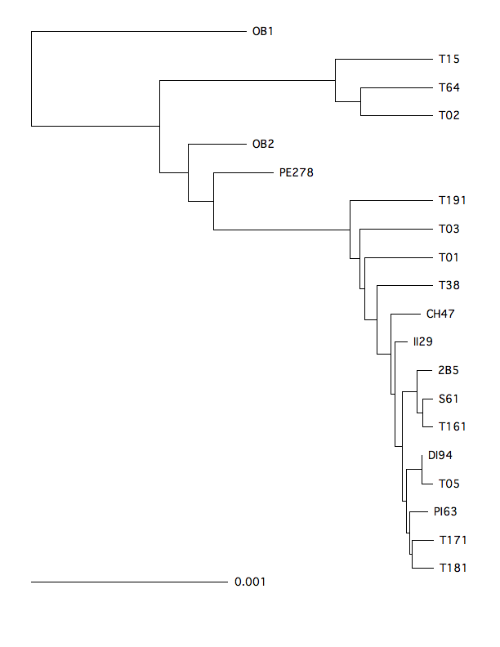
OB1 - 44,000
OB2 - 44,000
PE278 - 37,570
II29 - 6,082
DI94 - 5,030
P163 - 1,258
2B5 - 275

Figure S2. Serial UPGMA tree based on the complete mitogenomes from ancient and modern populations of Adelie penguins. This tree was constructed by using the software Pebble that accounts for the ages of the ancient sequences (Drummond and Rodrigo, 2000). Carbon dated ages of ancient sub-fossil bones are given in the box.
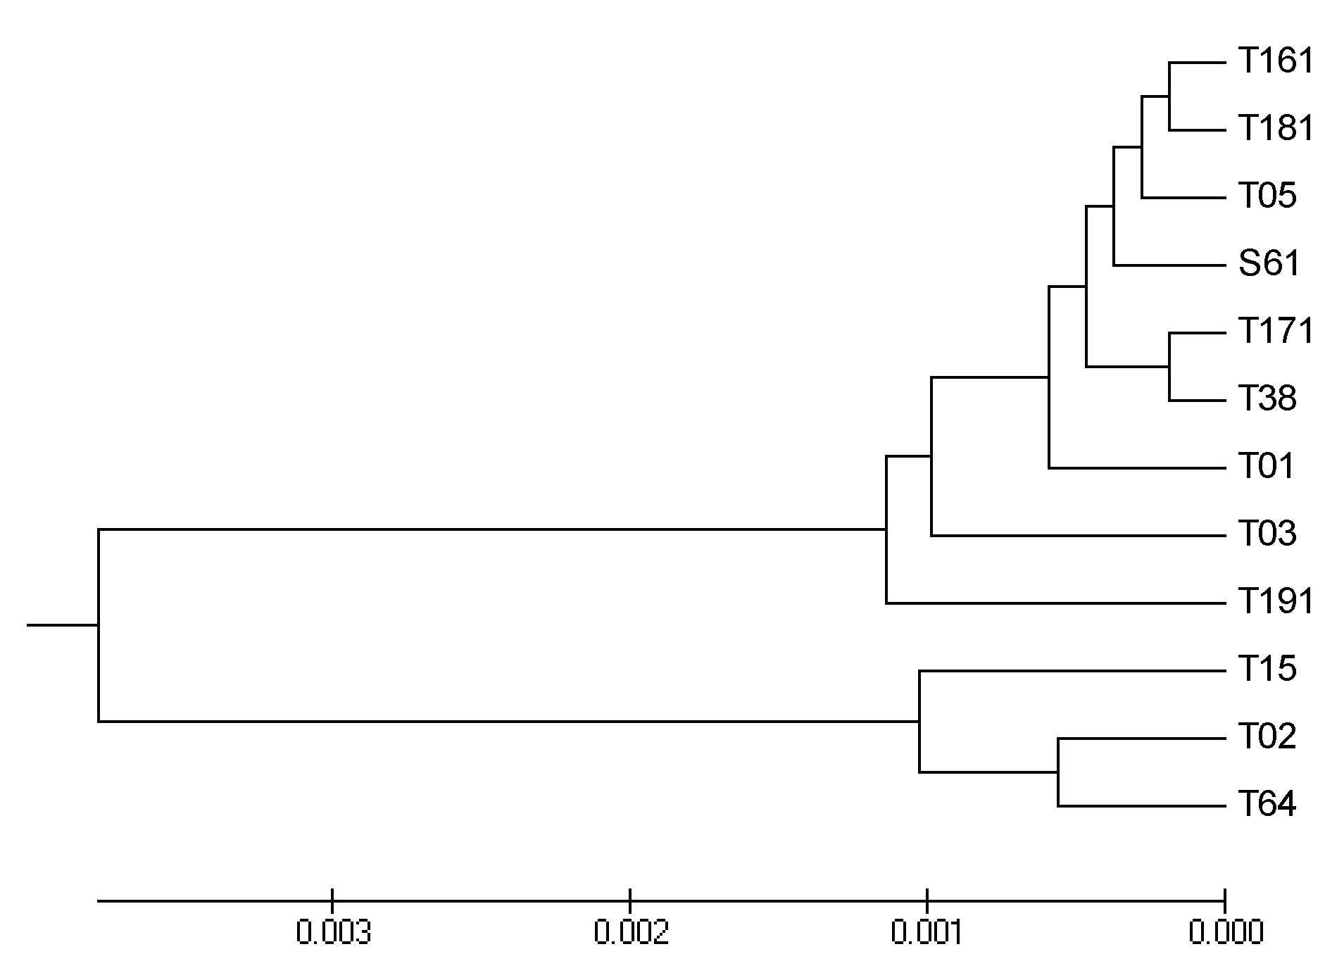
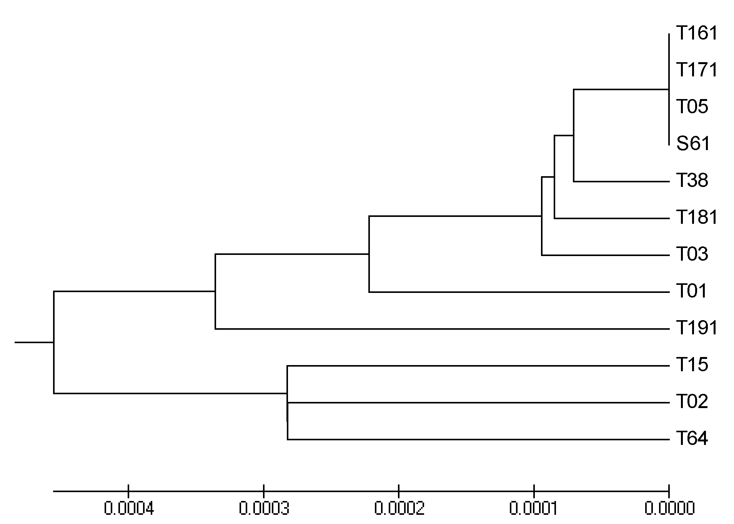
A
A
R
R
A-R
A-R
a
b

Figure S3. UPGMA trees of modern Adelie penguins. Trees were constructed using a. synonymous sites b. constrained sites (nonsynomymous sites +tRNAs+rRNAs). The nodes show the two distinct Antarctic (A) and Ross sea (R) lineages, which coalesce at the root (A-R).

References
- Römpler et al. (2006) Multiplex amplification of ancient DNA. Nature Protocols 1: 720-728.
2. Larkin, M., G. et al. (2007). Clustal W and Clustal X version 2.0. Bioinformatics 23: 2947-2948.
3. Tamura, et al. (2007). MEGA4: Molecular Evolutionary Genetics Analysis (MEGA) software version 4.0. Mol Biol Evol 24: 1596-1599.
4. Drummond, A. and Rodrigo, A.G. (2000). Reconstructing genealogies of serial samples under the assumption of a molecular clock using serial-sample UPGMA. Mol Biol Evol 17: 1807-1815.
5. Rambaut, A. (2000). Estimating the rate of molecular evolution: incorporating non-contemporaneous sequences into maximum likelihood phylogenies. Bioinformatics 16, 395-399.
6. Drummond, A. and Rambaut, A. (2007). BEAST: Bayesian evolutionary analysis by sampling trees. BMC Evol Biol 7: 214.
7. Rambaut, A. and Drummond, A.J. (2004). Tracer. University of Oxford. Oxford.
8. Yang, Z. (2007). PAML 4: phylogenetic analysis by maximum likelihood. Mol Biol Evol 24: 1586-1591.
9. Rannala, B., and Yang, Z.H. (2003) Bayes estimation of species divergence times and ancestral population sizes using DNA sequences from multiple loci. Genetics 164, 1645-1656

Corresponding author: Lambert, D.M. (d.lambert@griffith.edu.au).

